**CASE STUDY 2 – LBJ 2021**

**by**

**Rushikesh Bodke**

**2021Oct@02324**

**ACEIT, Jaipur**

**Web Based Case Study**

The requirement is to develop a Web application which will read data from a .csv file and perform various operations mentioned below.

➢ Create a csv file by the name **students.csv** with the following content:

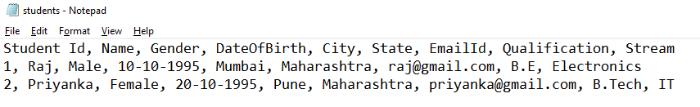

➢ This application should be developed using combination of client/server web technologies. For the client side code, combination of HTML/CSS/JS should be used and for the server side code, you can use any technology of choice like Servlet/JSP/PHP/.NET/Python.

➢ Create an **index.html** page which will display the following options to the user:

* + Add new Student
  + Search for a Student by Id
  + Display all the Students

➢ Based on the selection done by the user, create separate pages for processing the request accordingly.

* **Step 1:** create **add-student.html** page which will display a form to the user like this:

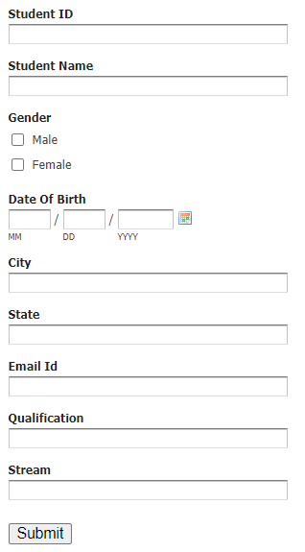

* When the user submits the form, some server side code should be written to save the data in the students.csv file.
* **Step 2:** create a page called as **search-student.html** file which will look like this:

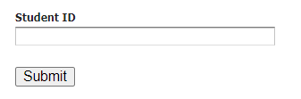

* When the user submits this form, some server side code should read the data from the csv file and display the same to the user like this:

|  |  |
| --- | --- |
| **Student ID** | 1 |
| **Student Name** | Raj |
| **Gender** | Male |
| **DateOfBirth** | 10-10-1995 |
| **City** | Mumbai |
| **State** | Maharashtra |
| **EmailId** | raj@gmail.com |
| **Qualification** | B.E |
| **Stream** | Electronics |

* Similarly try to complete the 3rd scenario which will display all the students data in an HTML page.

**----------------------------------------------------------------------------------------------------------------------------**

**Technology used**: HTML5, CSS3, PYTHON, Flask

**Editor**: Visual Studio Code

**APPROACH:**

* Create the CSV file (students.csv) to store the details of the Students.
* Write a Flask Server using Python, which redirects the user to different routes.
* The Flask Server should also be able to read, write and manipulate the data in the CSV file.
* Create a main HTML page (index.html) which redirects the user to the desired pages.
* Create an add-student.html page which has a form that collects the student data entered and sends it to the back-end sever to store in the students.csv file.
* Create a search-student.html page through which the user searches for students’ details using the student Id. The id is sent to the back-end server which then matches the id with the data in the students.csv file and a linear search algorithm is performed on the data to find the correct student record.
* Create a display-students.html page that displays the details of all the students recorded in the students.csv file.

**students.csv file:**

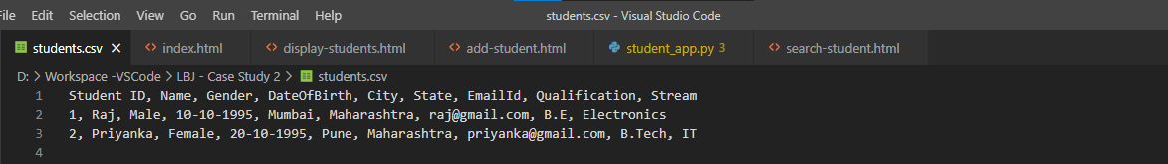

**index.html:**

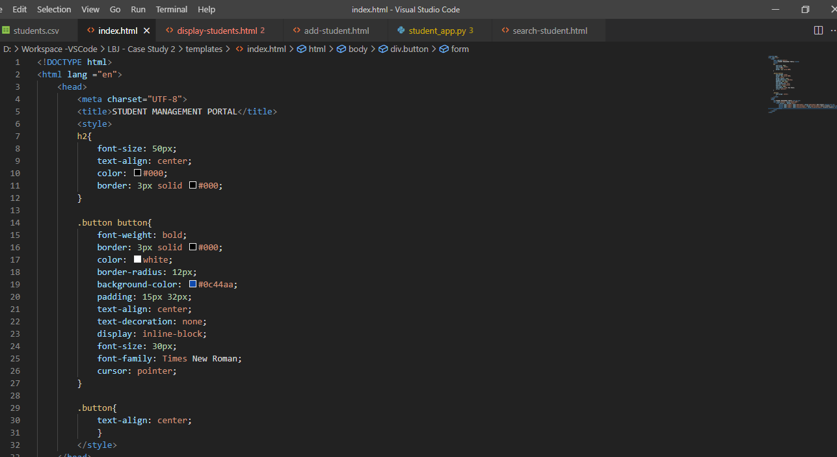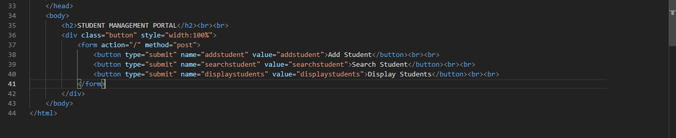

**add-student.html**

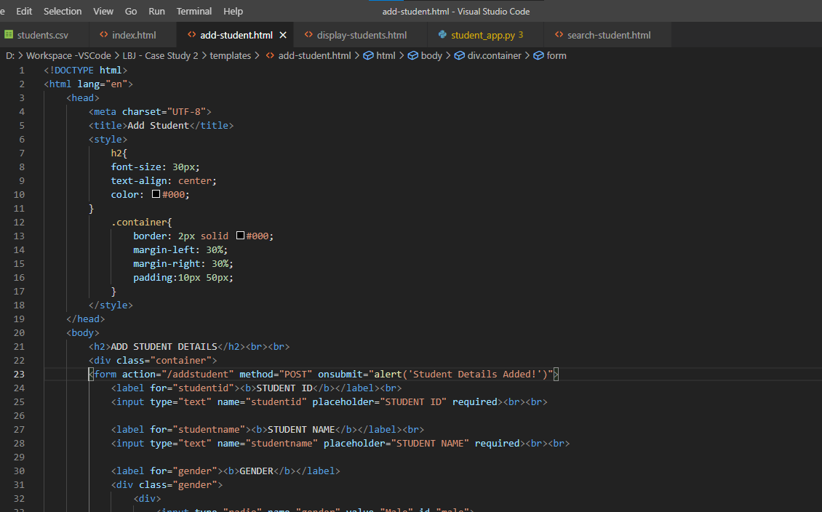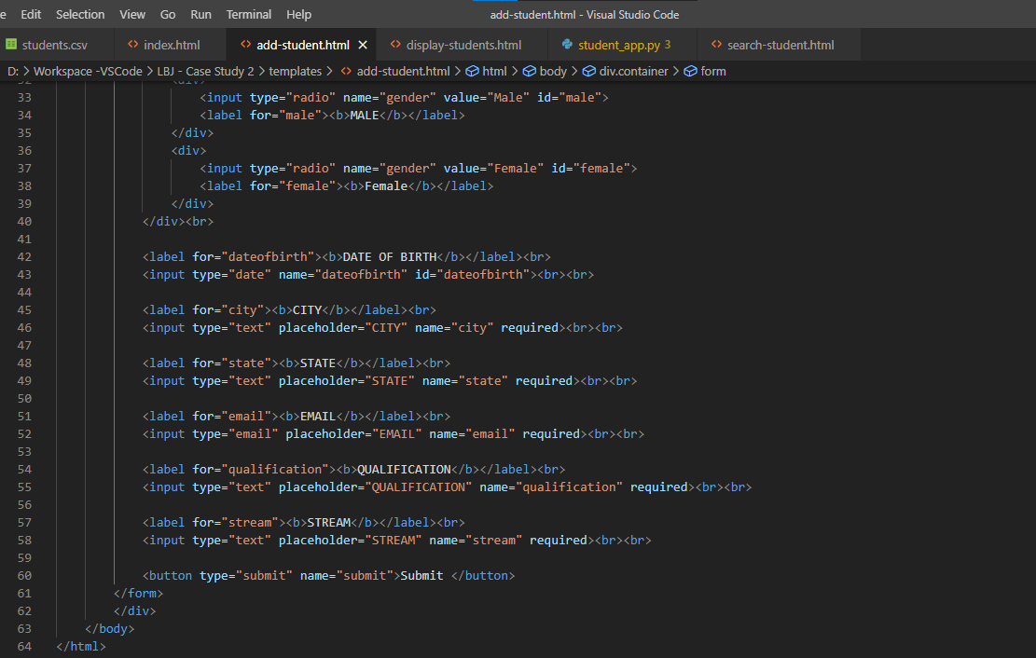

**search-student.html**

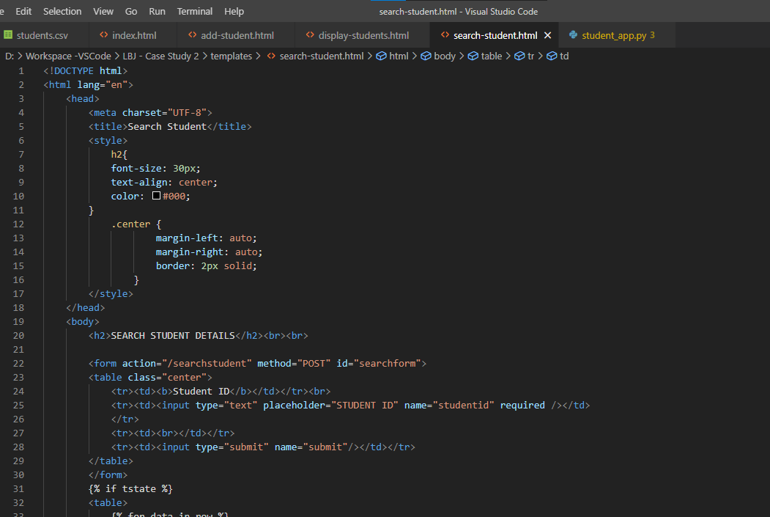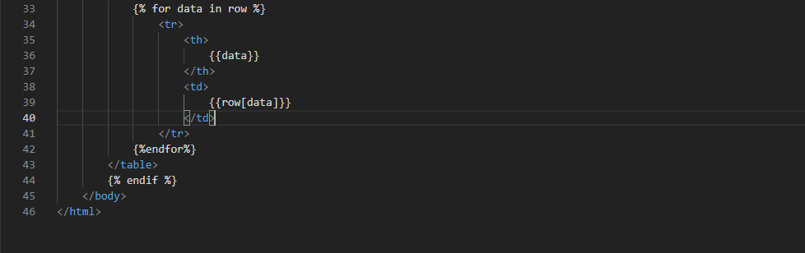

**display-students.html:**

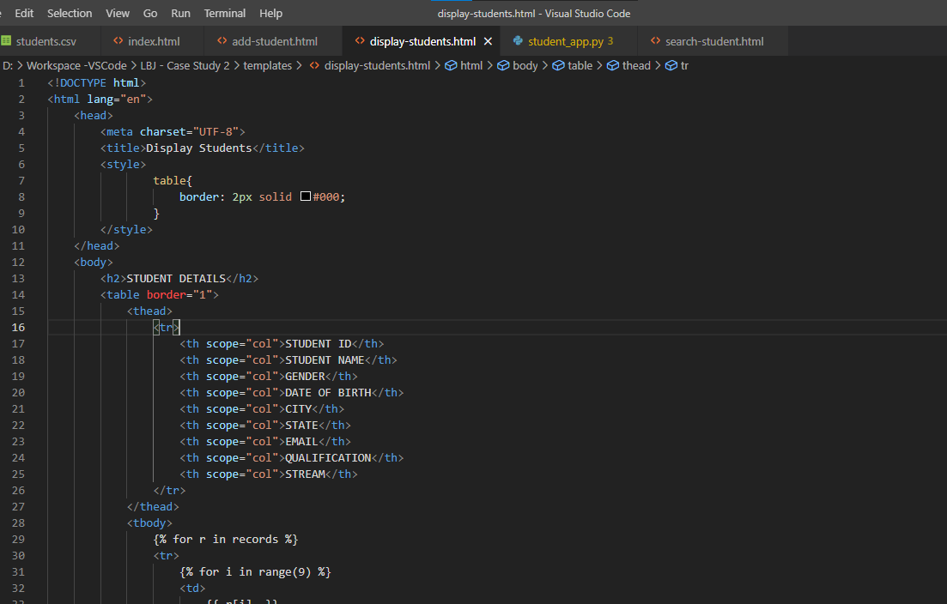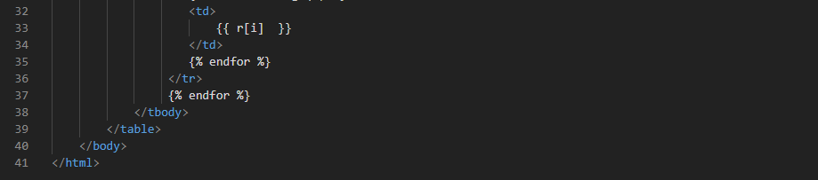

**student_app.py:**

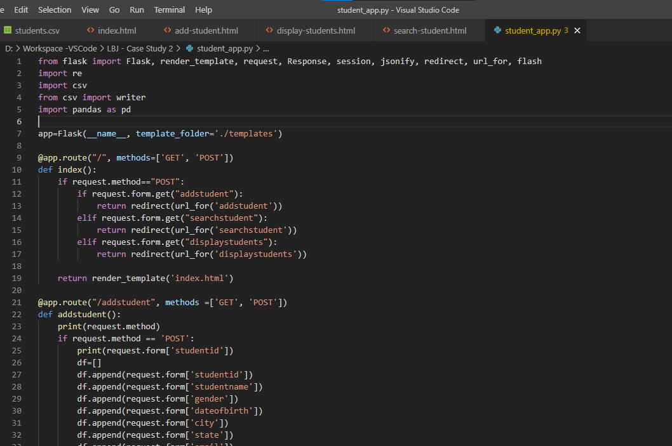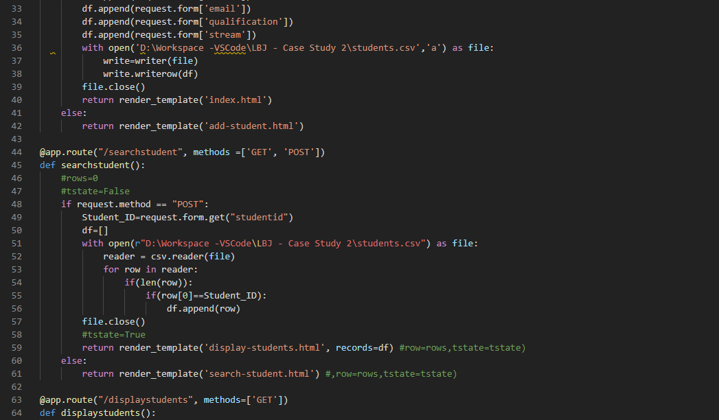

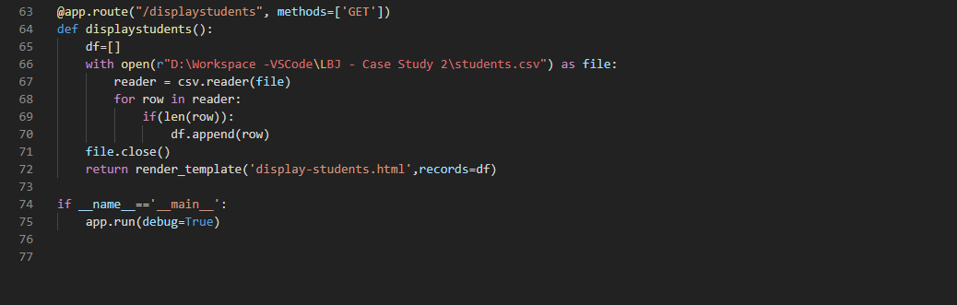  
  
**OUTPUT:**

**index.html**

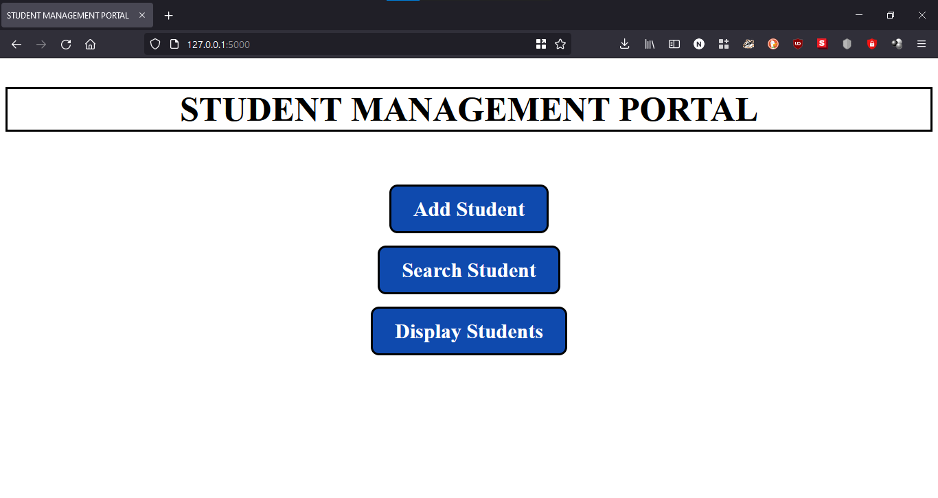

**add-student.html:**

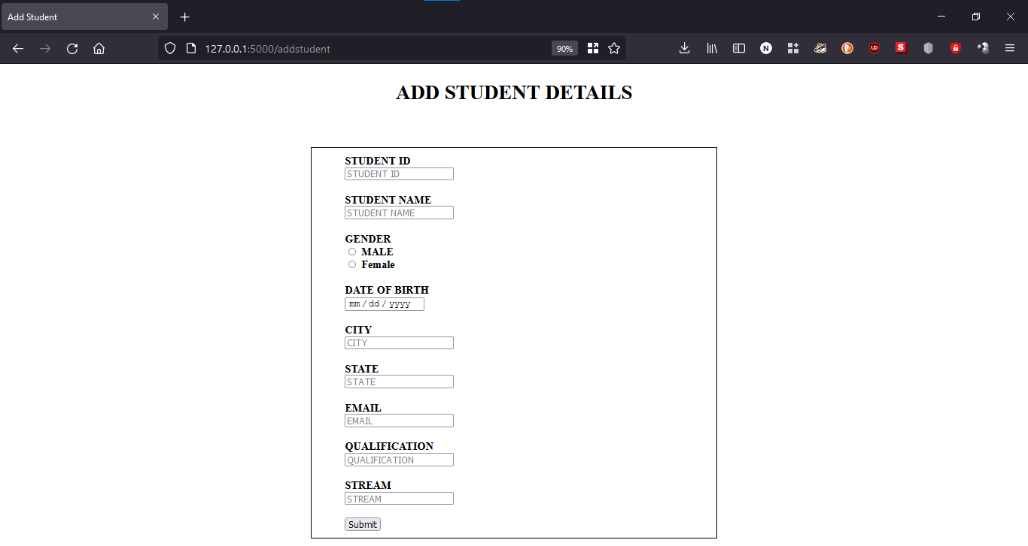 **search-student.html:**

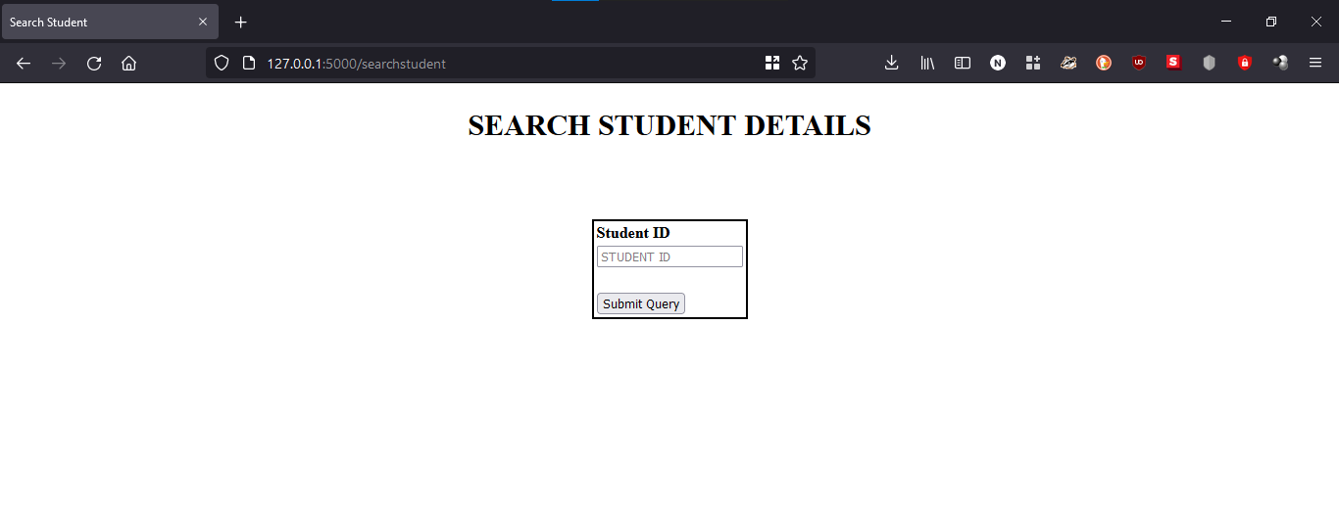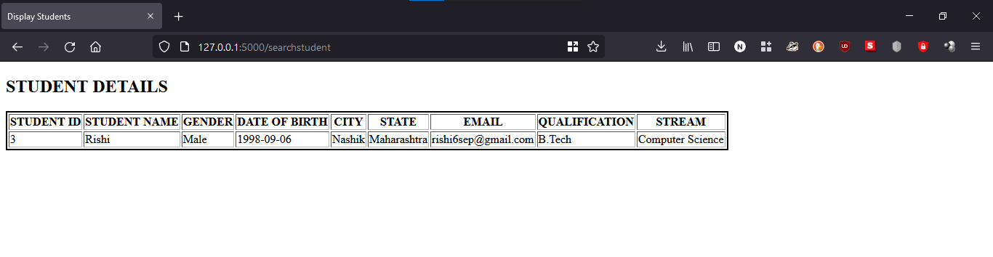

**display-students.html:**

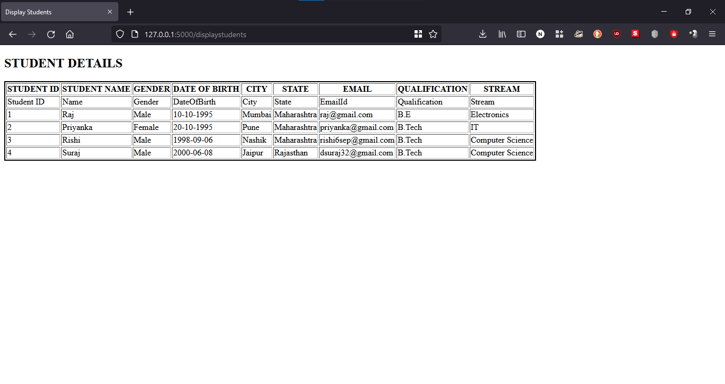 **students.csv after new entires:**

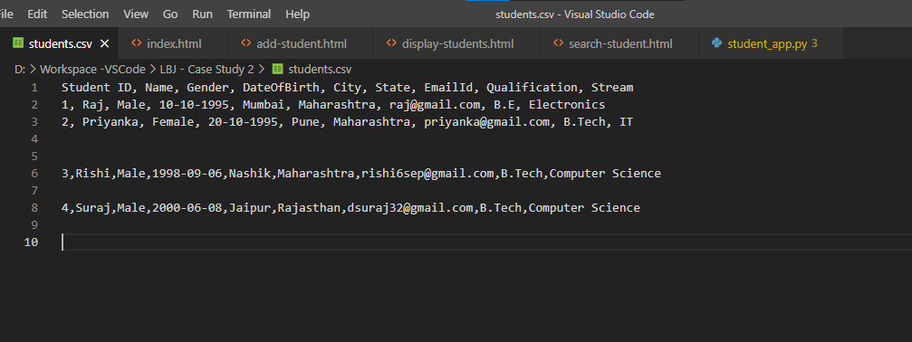 **Github repository link:** [**https://github.com/rishi698/Student-Management-Portal**](https://github.com/rishi698/Student-Management-Portal)